Logistic regression

Linear reg predict continuous (ex: house price)
Logistic regression predicts categorical outcomes / binary ex: yes or no, 0 or 1
Ex predicting whether a person diabetes based on blood sugar level

Sigmoid function
It’s a mathematical function that maps any real value number into a range between 0 & 1

Formula

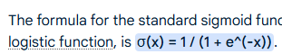

In this formula, 'x' represents the input, 'e' is Euler's number (approximately 2.718), and 'σ(x)' is the output of the sigmoid function, which is always a value between 0 and 1, forming an S-shaped curve

- e^(-x):
This is the exponential function with a negative exponent. The value of e^(-x) approaches 1 when x is 0, approaches 0 as x becomes large and positive, and approaches infinity as x becomes large and negative.

Key Characteristics:
- S-Shaped Curve: The function produces a smooth, S-shaped curve.
- Output Range: The output of the sigmoid function always falls between 0 and 1, making it useful for interpreting results as probabilities.
- Smooth and Continuous: The function is smooth and continuous, which is important for gradient-based optimization methods used in machine learning.

Univariate Log regre
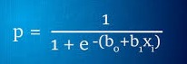

At x =0 , S(x) = 0.5

Significance
- Probability interpretation
  - Since output lies between 0 and 1, that is the reason used in classification problems

Gradient based optimization (like backpropagation in neural networks)

Threshold decision
- If output > 0.5 predict class 1
- If output < 0.5 predict class 0
Predict whether student pass(1) or fail(0) based on hours studied
x=hours studied
2 hours studied
S(x) = 1 / 1 + e^-2 0.88 88% chance of pass
X=-2
S(x) = ~0.12 12% chance of pass
Then Use above Probability to make predictions

Likelihood function
This tells how likely the observed data is, given a model with certain parameters
--
The likelihood function formula defines the probability of observing a particular dataset,
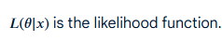
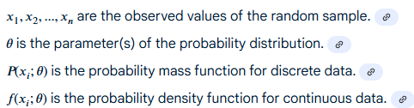

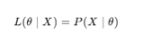
X = observed data
Theta model parameters
P(X/Theta) probability of seeing the data for those parameters

ML Context
Parameter estimation (MLE – maximum likelihood estimation)
- Use likelihood to find parameters that make observed data most probable
ML algorithms

Likelihood function – measures how well a particular sigmoid curve fits the data

ODDs and Log ODDs

Odds
- Probability is between 0 & 1
- Odds represent the ratio of success vs failure

Odds = P(Success) / 1-P(Success)
Ex
Probability of rolling a 6. P = 1/6 ~0.167
Odds = 0.167 / 1-0.167 = 0.167/0.833 = 0.20 1 to 5 Odds

Log – Odds (log of it)

- Log (P/1-P)
If P = 0.5 Odds = 1 Log Odds = 0
If P < 0.5 Odds < 1 Log Odds < 0
If P > 0.5 Odds > 1 Log Odds > 0
Log Odds helps to turn probabilities into a linear scale

ML context
Linear relationship with features
Logistic regression model log odds as a linear function of input features
Log (P/P-1) = w.x + b
- Coefficient w means for each unit increase in x, the log odds increase by w
Odds – its giving a ratio of success vs failure
Log – Odds provide a linear function – which is more suitable for ML models

